F:\Picsart_23-06-19_23-03-12-777.png

F:\Picsart_23-06-19_23-03-12-777.png

**Dept.of Commerce & Management**

**Commerce Association-'Jnanagni'**

**Report on "Business Quiz" Event**

Convenor: J. Manjunatha Rao

Members: Smt.Soujanya

Smt.Madhura

Secretary: Kavya Venkatesh (3rd B.com'A')

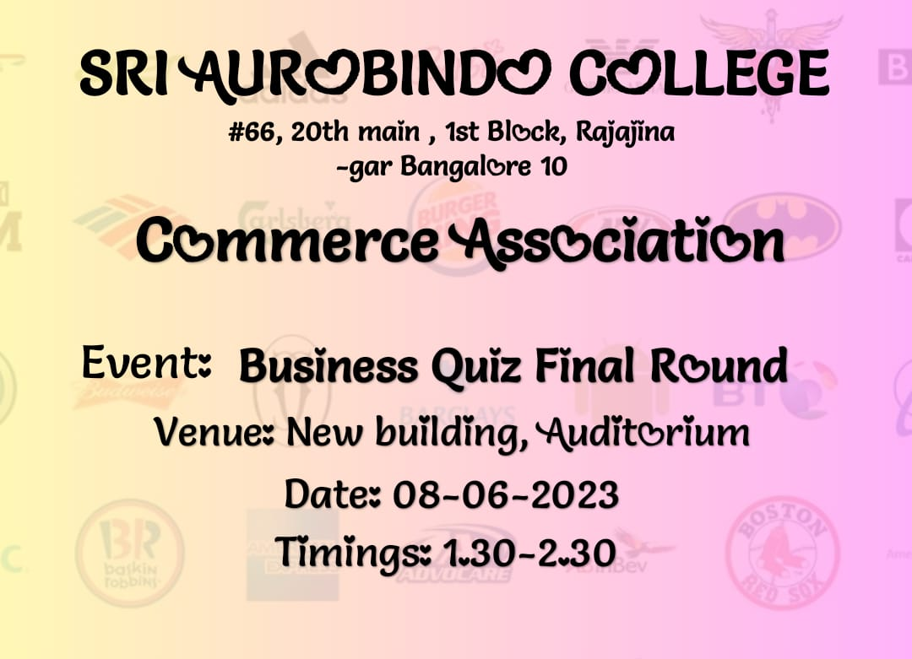

**DATE:**

**COMMERCE ASSOCIATION**

**Name of the Event: "Business Quiz"**

**Objective of the Event:** To evaluate the knowledge of the participants within academics as well as non academics.

**Outcome of the Event:** Participants showcased their knowledge on the topics asked in different levels in the quiz.

**Target Audience:** College Students

**A Brief Report :**

Commerce Association organised an event "Business Quiz" Event with 2 levels on different dates.

🟏Business Quiz Prelims Round.

🟏Business Quiz Final Round.

In Final round there are totally 5 rounds.

The circular was sent in advance to all B.com students.

Both the rounds was conducted in Auditorium(New Building) from 1:30pm to 2:30pm.

* **Business Quiz Prelims Round:** Prelims round was conducted on Friday(16/12/2022).

Students were participated individually. They were given a paper of 15 MCQ questions.

* Totally 35 students were participated, among those 21 students were short-listed for final round of Business Quiz.

The short-listed students names was displayed on the notice board and circular was sent on this notice to all B.com classes.

* **Business Quiz Final Round:** Final round was conducted on Thursday(08/06/2023).
* The short-listed 21 students were made as a team, in which each team had 5 members, but 1 left out student was added and to one among 4 teams by picking a chit of team names.

**🟏 Final Round had 5 rounds**:

**1st Round- Tagline Identification.**

**2nd Round- Logo Identification.**

**3rd Round- Product Identification.**

**4th Round- Personality Identification.**

**5th Round- Rapid Round.**

* **Rules of the Round:**

🟑For first 4 rounds there will be 1 question for each team.

🟑Each question carries 10 marks except Rapid round.

🟑Pass questions carries 5 marks.

🟑Rapid round consists total 5 questions for each team which carries 10 marks for a team.

**There were 4 Teams named as**

**Team 1- Kadamba.**

**Team 2- Chalukya.**

**Team 3- Hoysala.**

**Team 4- Chola.**

* Based on the points they have scored in all 5 Rounds.

The highest points scored and the Winner of Business Quiz is Team (Chalukya).

**Winners of Business Quiz Event**

|  |  |  |  |
| --- | --- | --- | --- |
| **Teams** | **Names** | **Class** | **Place** |
| 01 | Yashas | 3rd B.com | 1st Place |
| (Chalukya) | Harsha G | 3rd B.com |  |
|  | Prem Kumar | 3rd B.com |  |
|  | Monisha | 3rd B.com |  |
|  | Srinivas | 1st B.com |  |
|  |  |  |  |
| 02 | Likitha R | 3rd B.com | 2nd Place |
| (Hoysala) | Leela B.K | 2nd B.com |  |
|  | Elangovan | 3rd B.com |  |
|  | Rakshitha S.P.C | 3rd B.com |  |
|  | Shruthi.Hs | 3rd B.com |  |
|  | Shwetha Yadav | 3rd B.com |  |
|  |  |  |  |
| 03 | Anusha H.R | 3rd B.com | 3rd Place |
| (Kadamba) | Anusha A | 3rd B.com |  |
|  | Manasa Chinnu | 3rd B.com |  |
|  | Prajwal | 3rd B.com |  |
|  | Manoj | 1st B.com |  |
|  |  |  |  |
| 04 | Uma K | 2nd B.com | Consolation |
| (Chola) | Harshitha KS | 3rd B.com |  |
|  | Velan | 3rd B.com |  |
|  | Bhavani M | 2nd B.com |  |
|  | Deepika | 3rd B.com |  |

**Business Quiz Event**

**